**Week - 4**

1. **Create a Spring Web Project using Maven**

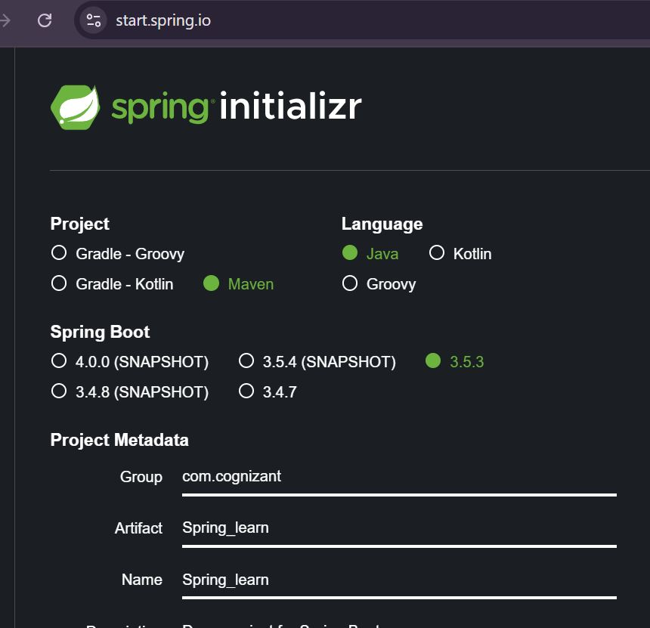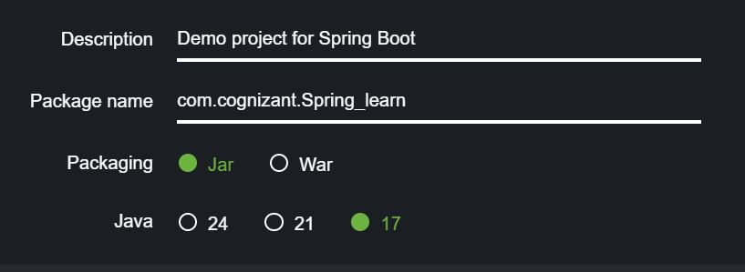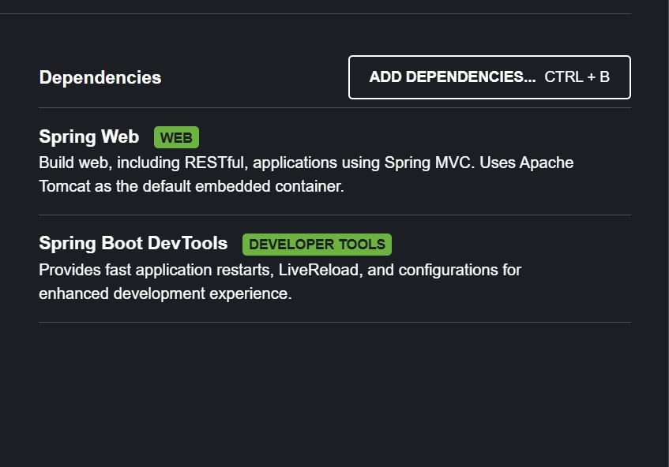

Downloading the packages via terminal

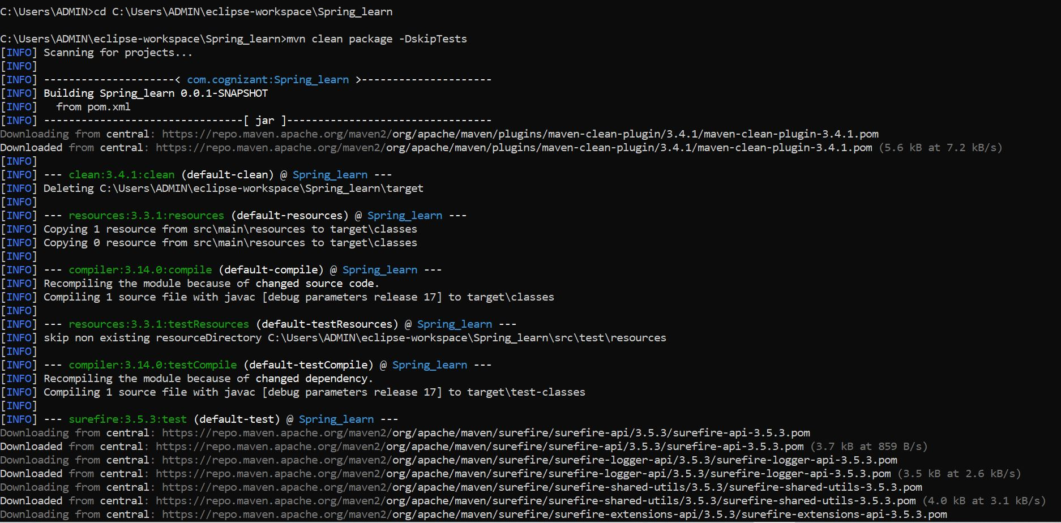

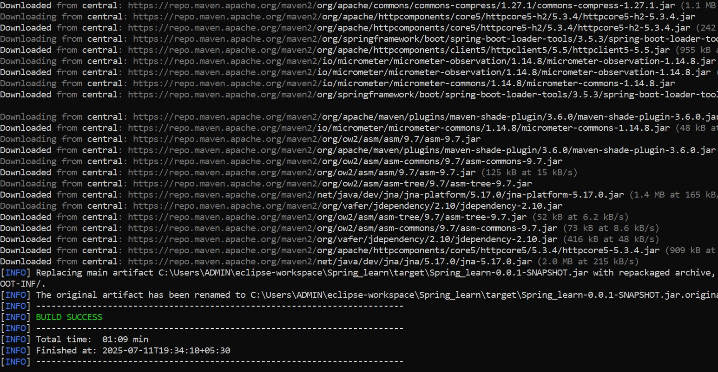

package com.cognizant.spring_learn;

import org.springframework.boot.SpringApplication;

*@*SpringBootApplication

public class SpringLearnApplication {

public static void main(String[] args) {

SpringApplication.*run*(SpringLearnApplication.class, args);

}

}

OUTPUT:

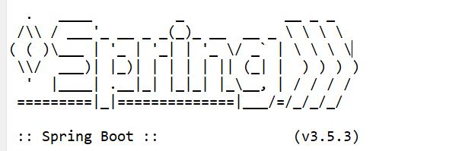

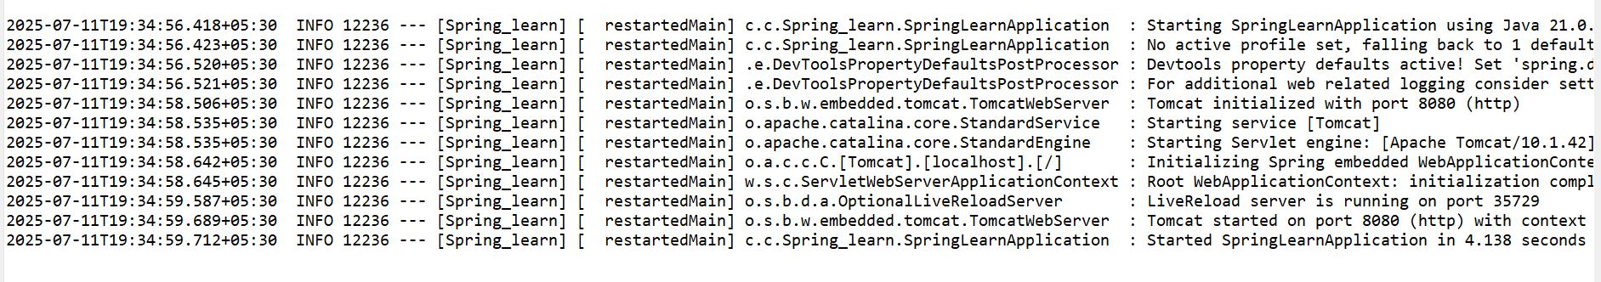

**Exercise - 2: Spring Core – Load Country from Spring Configuration XML**

package com.cognizant. Spring_learn;

import org.slf4j.Logger;

import org.slf4j.LoggerFactory;

public class Country

private static final Logger ***LOGGER*** = LoggerFactory.*getLogger*(Country.class);

private String code;

private String name;

public Country() {

}

LOGGER.debug("Inside Country Constructor");

public String getCode() {

LOGGER.debug("Getting code");

return code;

}

public void setCode(String code) {

LOGGER.debug("Setting code"); this.code = code;

}

public String getName() {

LOGGER.debug("Getting name"); return name;

}

public void setName(String name) { LOGGER.debug("Setting name"); this.name = name;

}

*@*Override

public String toString() {

return "Country [code=" + code + ", name=" + name + "]";

}

}

<?xml version="1.0" encoding="UTF-8"?>

<beans xmlns="http://www.springframework.org/schema/beans" xmlns:xsi="http://www.w3.org/2001/XMLSchema-instance" xsi:schemaLocation="http://www.springframework.org/schema/beans

http://www.springframework.org/schema/beans/spring-beans.xsd">

<bean id="country" class="com.cognizant. Spring_learn. Country"> <property name="code" value="IN"/>

<property name="name" value="India"/>

</bean>

</beans>

OUTPUT:

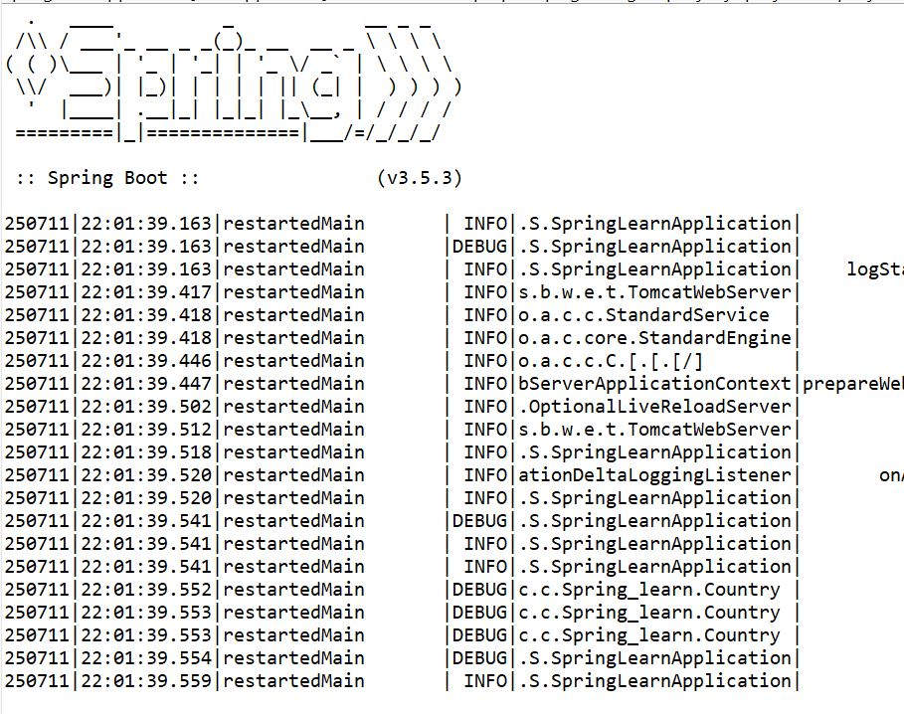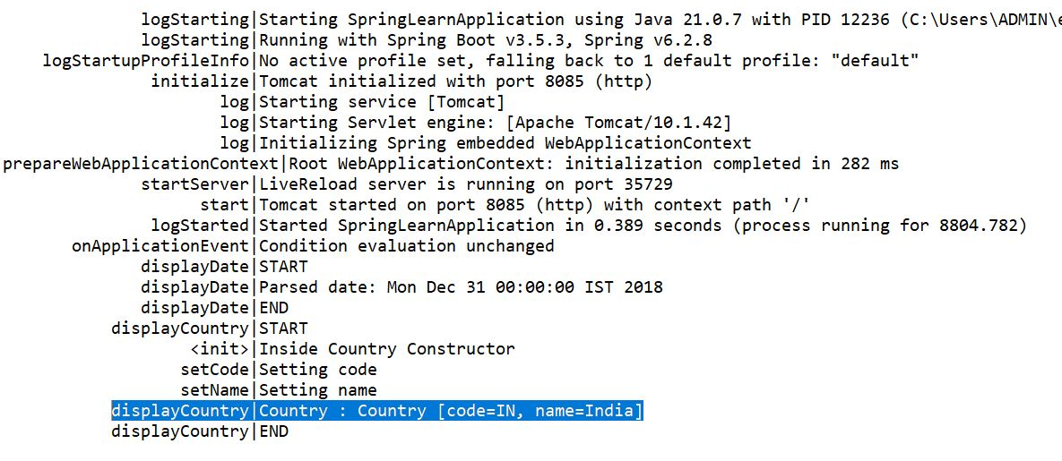

**Exercise - 3: Hello World RESTful Web Service Hello World RESTful Web Service**

package com.cognizant. Spring_learn.controller;

import org.slf4j.Logger;

import org.slf4j.LoggerFactory;

import org.springframework.web.bind.annotation.GetMapping;

import org.springframework.web.bind.annotation. RestController;

*@*RestController

public class HelloController {

private static final Logger ***LOGGER*** = LoggerFactory.*getLogger* (HelloController.class);

*@*GetMapping("/hello")

public string sayHello() {

***LOGGER***.info("START sayHello()");

String message = "Hello World!!";

***LOGGER***.info("END sayHello()");

return message;

}

}

package com.cognizant. Spring_learn;

import org.springframework.boot.SpringApplication;

import org.springframework.boot.autoconfigure. SpringBootApplication;

import org.springframework.context.annotation.ComponentScan;

*@SpringBootApplication*

*@ComponentScan* (basePackages = "com.cognizant.Spring_learn")

public class SpringLearnApplication {

public static void main(String[] args) {

SpringApplication.*run*(SpringLearnApplication.class, args);

}

}

OUTPUT:

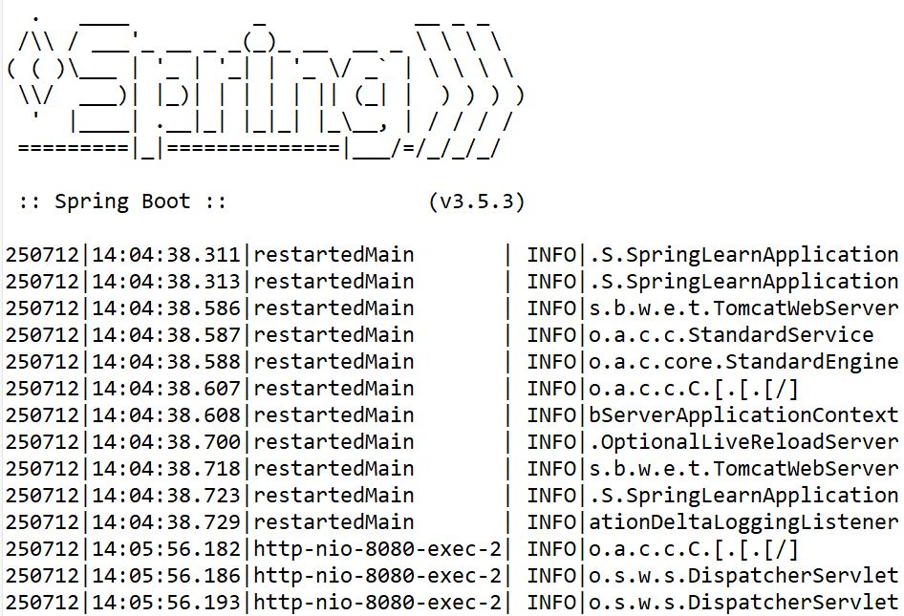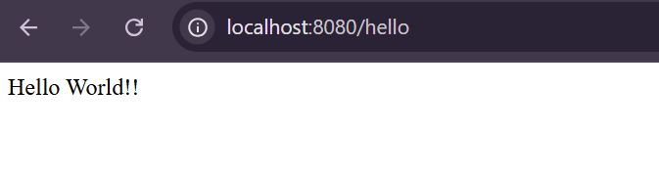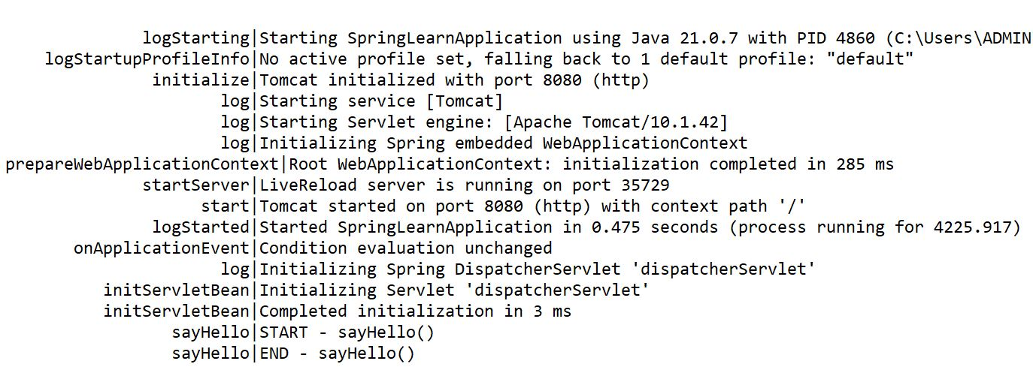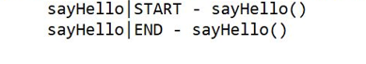

**Exercise - 4: REST Country Web Service**

package com.cognizant.Spring_learn;

public class Country {

private String code;

private String name;

public Country() {}

public String getCode() {

return code;

}

public void setCode(String code) {

this.code = code;

}

public String getName() {

return name;

}

public void setName(String name) {

this.name = name;

}

*@Override*

public String toString() {

return "Country [code=" + code + ", name=" + name + "]";

}

}

package com.cognizant.Spring_learn.controller;

import com.cognizant. Spring_learn.Country; import org.slf4j.Logger;

import org.slf4j.LoggerFactory;

import org.springframework.web.bind.annotation.GetMapping;

import org.springframework.web.bind.annotation. RestController;

*@*RestController

public class CountryController {

private static final Logger ***LOGGER*** = LoggerFactory.*getLogger*(CountryController.class);

*@*GetMapping("/country")

public Country getCountryIndia() { ***LOGGER***.info("START - getCountryIndia()");

Country country = new Country();

country.setCode("IN");

country.setName("India");

***LOGGER***.info("END - getCountryIndia()");

return country;

}

}

OUTPUT

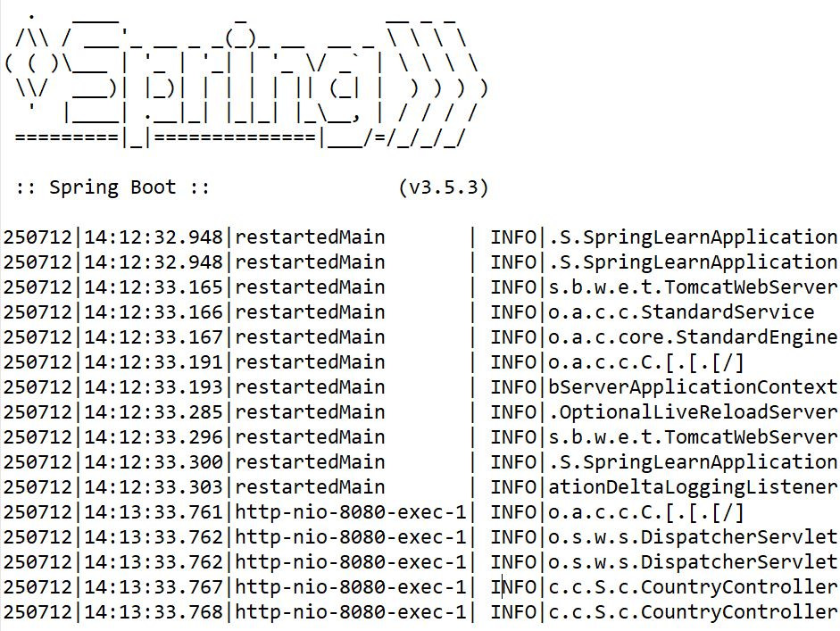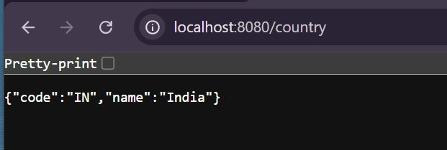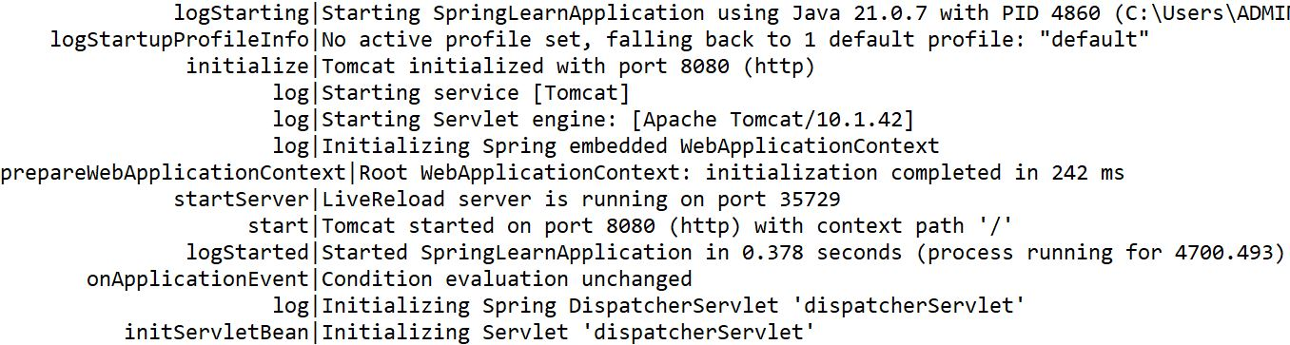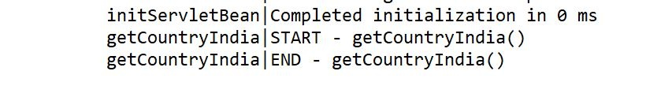

**Exercise - 4: REST - Get country based on country code**

http://www.springframework.org/schema/beans/spring-beans.xsd (xsi:schemaLocation) <?xml version="1.0" encoding="UTF-8"?>

<beans xmlns="http://www.springframework.org/schema/beans" xmlns:xsi="http://www.w3.org/2001/XMLSchema-instance" xsi:schemaLocation="http://www.springframework.org/schema/beans

http://www.springframework.org/schema/beans/spring-beans.xsd">

<bean id="in" class="com.cognizant.Spring_learn.Country">

<property name="code" value="IN"/>

<property name="name" value="India"/>

</bean>

<bean id="us" class="com.cognizant. Spring_learn. Country"> <property name="code" value="US"/>

<property name="name" value="United States"/>

</bean>

<bean id="cn" class="com.cognizant.Spring_learn. Country">

<property name="code" value="CN"/>

<property name="name" value="China"/>

</bean>

</beans>

package com.cognizant. Spring_learn.controller;

import com.cognizant.Spring_learn.Country;

import org.slf4j.Logger;

import org.slf4j.LoggerFactory;

import org.springframework.context.ApplicationContext;

import org.springframework.context.support.ClassPathXmlApplicationContext;

import org.springframework.web.bind.annotation.GetMapping;

import org.springframework.web.bind.annotation. PathVariable;

import org.springframework.web.bind.annotation. RestController;

*@*RestController

public class CountryController {

private static final Logger ***LOGGER*** = LoggerFactory.*getLogger*(CountryController.class);

*@*GetMapping("/country")

public Country getCountryIndia() {

LOGGER.info("START

getCountryIndia()");

Country country = new Country();

country.setCode("IN");

country.setName("India");

-

LOGGER.info("END getCountryIndia()");

return country;

}

*@*GetMapping("/countries/{code}")

public Country getCountry (*@*PathVariable String code) {

***LOGGER***.info("START - getCountry() for code: {}", code);

ApplicationContext context = new ClassPathXmlApplicationContext("country.xml"); Country country = (Country) context.getBean (code.toLowerCase());

***LOGGER***.info("END getCountry()");

return country;

}

}

OUTPUT:

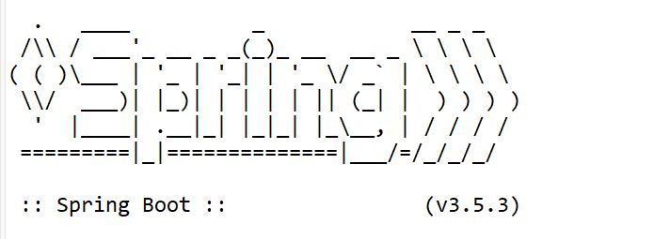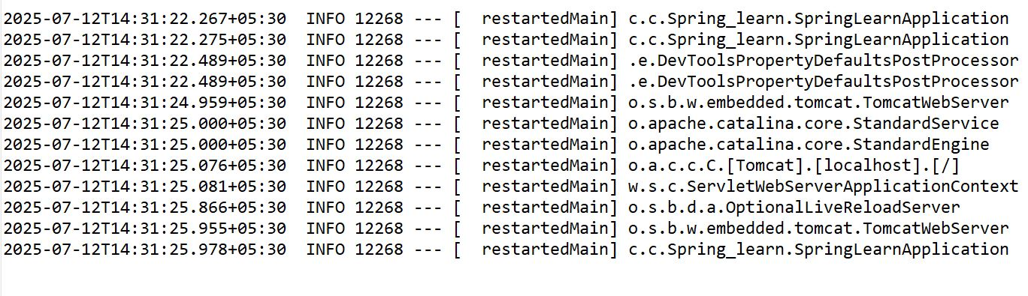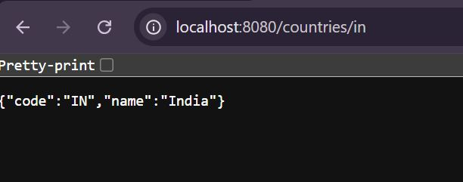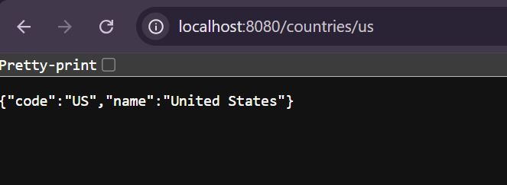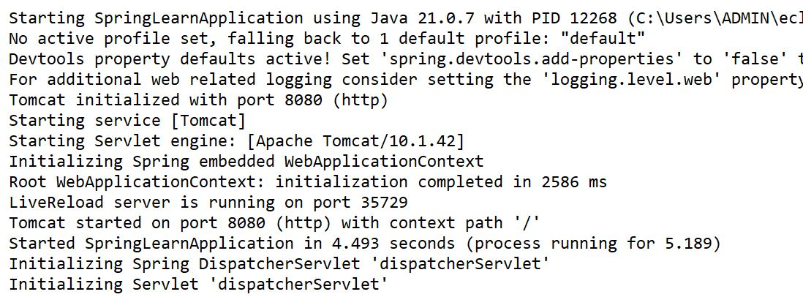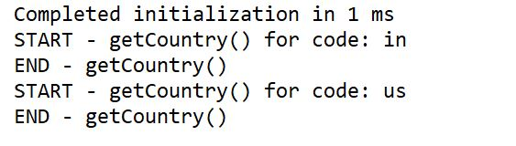

**Exercise - 6: Create authentication service that returns JWT**

import io.jsonwebtoken.Jwts;

import io.jsonwebtoken.SignatureAlgorithm;

import java.util.Date;

import java.util.HashMap;

import java.util.Map;

public class JwtAuthService {

private static final String ***SECRET_KEY*** = "mysecretkey123";

public static void main(String[] args) {

String username = "user1";

String token = *generateToken*(username);

System.***out***.println("Generated JWT Token: " + token);

}

public static String generateToken(String username) {

Map<String, Object> claims = new HashMap<>();

claims.put("sub", username);

claims.put("created", new Date());

return Jwts.builder()

.setClaims(claims)

.setExpiration(new Date(System.*currentTimeMillis*() + 1000 * 60 * 60))

.signWith(SignatureAlgorithm.HS512, ***SECRET_KEY***.getBytes())

.compact();

}

}

OUTPUT

****:



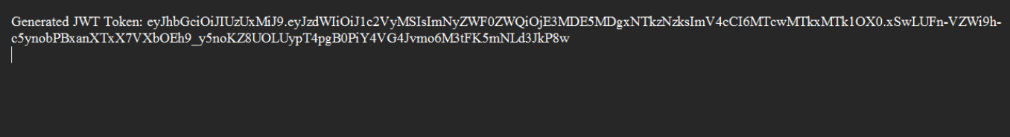

**3 spring-rest-handson**

**(Additional)**

**Handson - 1: Display Employee List and Edit Employee form using RESTful Web Service**

<?xml version="1.0" encoding="UTF-8"?>

<beans

xmlns="http://www.springframework.org/schema/beans" xmlns:xsi="http://www.w3.org/2001/XMLSchema-instance"

xsi:schemaLocation="

http://www.springframework.org/schema/beans

http://www.springframework.org/schema/beans/spring-beans.xsd">

<bean id="department1"

class="com.cognizant.Spring_learn.model.Department">

<property name="id" value="1" />

<property name="name" value="Human Resources" />

</bean>

<bean id="department2" class="com.cognizant.Spring_learn.model.Department">

<property name="id" value="2" />

<property name="name" value="Finance" />

</bean>

<bean id="skill1" class="com.cognizant.Spring_learn.model.Skill">

<property name="id" value="1" /> <property name="name" value="Java" />

</bean>

<bean id="skil12" class="com.cognizant.Spring_learn.model.Skill">

<property name="id" value="2" />

<property name="name" value="SQL" />

</bean>

<bean id="skil13" class="com.cognizant.Spring_learn.model.Skill">

<property name="id" value="3" />

<property name="name" value="Python" />

</bean>

<bean id="employee1" class="com.cognizant. Spring_learn.model. Employee"> <property name="id" value="1001" />

<property name="name" value="Ram" /> <property name="department" ref="department1" /> <property name="skills">

<list>

<ref bean="skill1" />

<ref bean="skill2" />

</list>

</property>

</bean>

<bean id="employee2" class="com.cognizant. Spring_learn.model.Employee"> <property name="id" value="1002" />

<property name="name" value="Kumar" /> <property name="department" ref="department2" /> <property name="skills">

<list>

<ref bean="skill2" /> <ref bean="skill3" />

</list>

</property>

</bean>

<bean id="employee3" class="com.cognizant. Spring_learn.model.Employee"> <property name="id" value="1002" />

<property name="name" value="Dinakar" /> <property name="department" ref="department2" /> <property name="skills">

<list>

<ref bean="skill3" />

</list>

</property>

</bean>

<bean id = "employeeList" class = "java.util.ArrayList">

<construstor-arg>

<list>

<ref bean = "employee1"/>

<ref bean = "employee2"/>

<ref bean = "employee3"/>

</list>

</constructor-arg>

</bean>

</beans>

package com.cognizant.Spring_learn.model;

public class Department{

private int id;

private String name;

public int getId() {

return id;

}

public Department() {}

public void setId(int id) {

this.id = id;

}

public String getName() {

return name;

}

public void setName(String name) {

this.name = name;

}

*@Override*

public String toString() {

return "Department [id=" + id + ", name=" + name + "]";

}

}

public com.cognizant.Spring_learn.model

public class Skill{

private int id;

private String name;

public Skill() {}

public int getId() {

return id;

}

public void setId(int id) {

this.id = id;

}

public String getName() {

return name;

}

public void setName(String name) {

this.name = name;

}

*@*Override

public String toString() {

return "Skill [id=" + id + ", name=" + name + "]";

}

}

package com.cognizant.orm_learn;

import java.util.List;

public class Employee{

private int id;

private String name;

private Department department;

private List<Skill> skills;

public Employee() {}

*@Override*

public String toString() {

return "Employee [id=" + id + ", name=" + name + ", department=" + department + ", skills=" + skills + "]";

}

public int getId() {

return id;

}

public void setId(int id) {

this.id = id;

}

public String getName() {

return name;

}

public void setName(String name) {

this.name = name;

}

public Department getDepartment() {

return department;

}

public void setDepartment(Department department) {

this.department = department;

}

public List<Skill> getSkills() {

return skills;

}

public void setSkills(List<Skill> skills) {

this.skills = skills;

}

}

package com.cognizant. Spring_learn.dao;

import com.cognizant. Spring_learn.model.Employee;

import org.springframework.context.ApplicationContext;

import org.springframework.context.support. ClassPathXmlApplicationContext; import org.springframework.stereotype. Repository;

import java.util.List;

*@Repository*

public class EmployeeDao {

public List<Employee> getAllEmployees () {

ApplicationContext context = new ClassPathXmlApplicationContext("employee.xml"); return context.getBean("employeeList", List.class);

}

}

package com.cognizant. Spring_learn.service;

import com.cognizant. Spring_learn.dao. EmployeeDao; import com.cognizant. Spring_learn.model.Employee;

import org.springframework.beans.factory.annotation.Autowired;

import org.springframework.stereotype.Service;

import java.util.List;

*@Service*

public class EmployeeService {

*@Autowired*

private EmployeeDao employeeDao;

public List<Employee> getAllEmployees () { return employeeDao.getAllEmployees();

}

}

package com.cognizant.Spring_learn.controller;

import com.cognizant.Spring_learn.model.Employee;

import com.cognizant. Spring_learn.service.EmployeeService;

import org.slf4j.Logger;

import org.slf4j.LoggerFactory;

import org.springframework.beans.factory.annotation.Autowired;

import org.springframework.web.bind.annotation. RestController;

import org.springframework.web.bind.annotation.GetMapping;

import java.util.List;

*@RestController*

public class EmployeeController {

private static final Logger ***LOGGER*** = LoggerFactory.*getLogger* (EmployeeController.class);

*@Autowired*

private EmployeeService employeeService;

*@GetMapping*("/employees")

public List<Employee> getAllEmployees () {

LOGGER.info("START - getAllEmployees ()");

List<Employee> employees = employeeService.getAllEmployees(); LOGGER.info("END - getAllEmployees()");

return employees;

}

OUTPUT

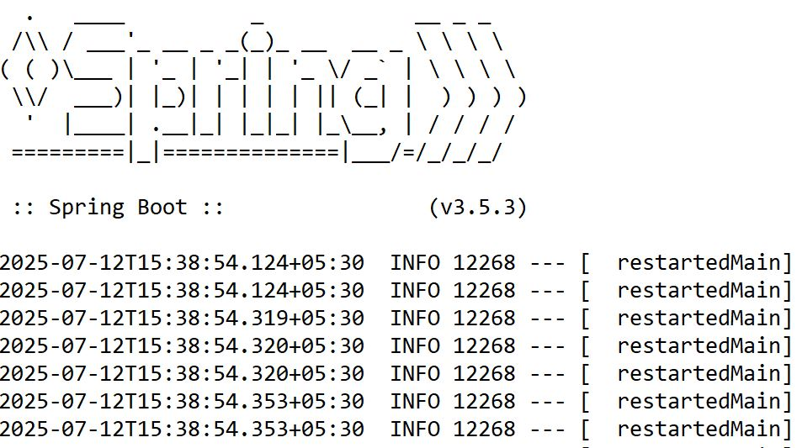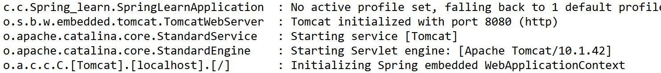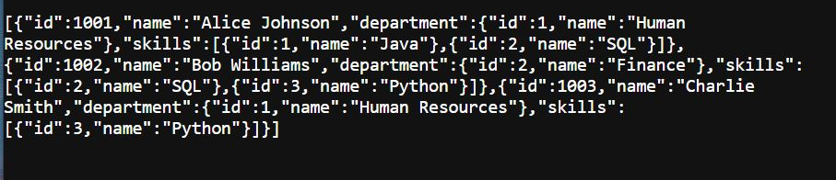

**Handson - 2: Create static employee list data using spring xml configuration**

package com.cognizant. Spring_learn.dao;

import com.cognizant. Spring_learn.model.Employee;

import org.springframework.context.ApplicationContext;

import org.springframework.context.support. ClassPathXmlApplicationContext; import org.springframework.stereotype. Repository;

import java.util.List;

*@Repository*

public class EmployeeDao {

public List<Employee> getAllEmployees () {

ApplicationContext context = new ClassPathXmlApplicationContext("employee.xml"); return context.getBean("employeeList", List.class);

for(Employee e: employeeList) {

if(e.getId() == id) return e;

}

return null;

}

}

<bean id = "employeeList" class = "java.util.ArrayList">

<construstor-arg>

<list>

<ref bean = "employee1"/>

<ref bean = "employee2"/>

<ref bean = "employee3"/>

</list>

</constructor-arg>

</bean>

</beans>

package com.cognizant. Spring_learn.service;

import com.cognizant. Spring_learn.dao. EmployeeDao; import com.cognizant. Spring_learn.model.Employee;

import org.springframework.beans.factory.annotation.Autowired;

import org.springframework.stereotype.Service;

import java.util.List;

*@Service*

public class EmployeeService {

*@Autowired*

private EmployeeDao employeeDao;

public List<Employee> getAllEmployees () { return employeeDao.getAllEmployees();

}

}

package com.cognizant.Spring_learn.controller;

import com.cognizant.Spring_learn.model.Employee;

import com.cognizant. Spring_learn.service.EmployeeService;

import org.slf4j.Logger;

import org.slf4j.LoggerFactory;

import org.springframework.beans.factory.annotation.Autowired;

import org.springframework.web.bind.annotation. RestController;

import org.springframework.web.bind.annotation.GetMapping;

import java.util.List;

*@RestController*

public class EmployeeController {

private static final Logger ***LOGGER*** = LoggerFactory.*getLogger* (EmployeeController.class);

*@Autowired*

private EmployeeService employeeService;

*@GetMapping*("/employees")

public List<Employee> getAllEmployees () {

LOGGER.info("START - getAllEmployees ()");

List<Employee> employees = employeeService.getAllEmployees(); LOGGER.info("END - getAllEmployees()");

return employees;

}

*@*GetMapping("/employees")

public List<Employee> getAllEmployees () {

}

LOGGER.info("START - getAllEmployees()");

List<Employee> employees = employeeService.getAllEmployees(); LOGGER.info("END getAllEmployees ()");

return employees;

-

*@*GetMapping("/employees/{id}")

public Employee getEmployeeById(*@*PathVariable int id) { LOGGER.info("START - getEmployeeById({})", id);

Employee employee = employeeService.getEmployeeById(id); LOGGER.info("END-getEmployeeById” );

return employee;

}

}

OUTPUT:

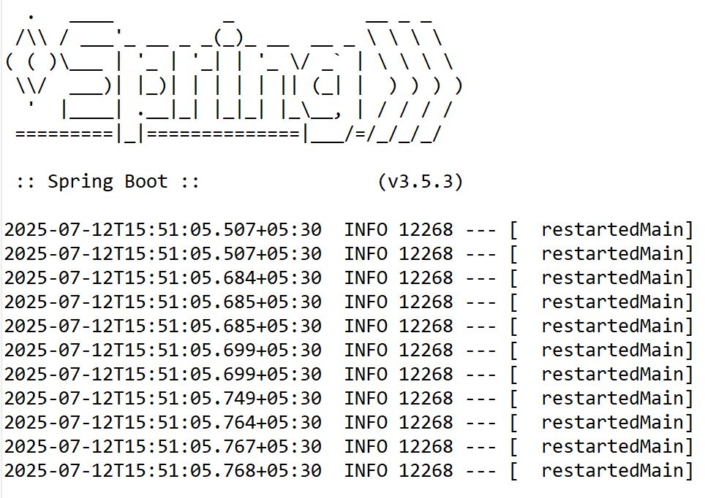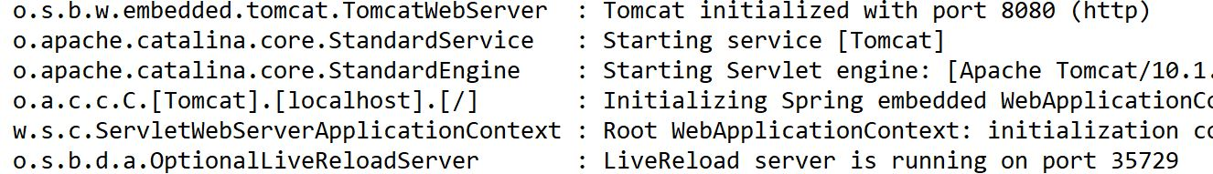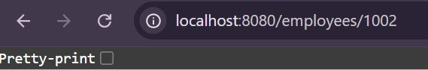

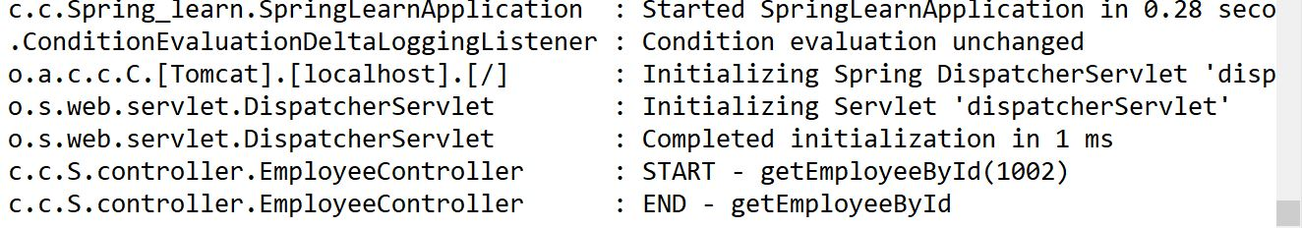

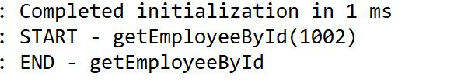

**Handson - 3: Create REST service to gets all employees**

package com.cognizant.Spring_learn.dao;

import com.cognizant. Spring_learn.model.Employee; import org.springframework.context.ApplicationContext;

import org.springframework.context.support.

ClassPathXmlApplicationContext;

import org.springframework. stereotype. Repository;

import java.util.List;

*@Repository*

public class EmployeeDao {

private static List<Employee> *employeeList*;

public List<Employee> getAllEmployees() {

if (employeeList == null) { ApplicationContext context = new

}

ClassPathXmlApplicationContext("employee.xml");

employeeList = context.getBean("employeeList", List.class);

return employeeList;

}

public Employee getEmployeeById(int id) {

List<Employee> list = getAllEmployees();

for(Employee e : list) {

if(e.getId() == id) return e;

}

return null;

}

}

package com.cognizant. Spring_learn.service;

import com.cognizant. Spring_learn.dao. EmployeeDao; import com.cognizant. Spring_learn.model.Employee;

import org.springframework.beans.factory.annotation.Autowired;

import org.springframework.stereotype.Service;

import java.util.List;

*@Service*

public class EmployeeService {

*@Autowired*

private EmployeeDao employeeDao;

public List<Employee> getAllEmployees () { return employeeDao.getAllEmployees();

}

}

package com.cognizant.Spring_learn.controller;

import com.cognizant.Spring_learn.model.Employee;

import com.cognizant. Spring_learn.service.EmployeeService;

import org.slf4j.Logger;

import org.slf4j.LoggerFactory;

import org.springframework.beans.factory.annotation.Autowired;

import org.springframework.web.bind.annotation. RestController;

import org.springframework.web.bind.annotation.GetMapping;

import java.util.List;

*@RestController*

public class EmployeeController {

private static final Logger ***LOGGER*** = LoggerFactory.*getLogger* (EmployeeController.class);

*@Autowired*

private EmployeeService employeeService;

*@GetMapping*("/employees")

public List<Employee> getAllEmployees () {

LOGGER.info("START - getAllEmployees ()");

List<Employee> employees = employeeService.getAllEmployees(); LOGGER.info("END - getAllEmployees()");

return employees;

}

*@*GetMapping("/employees")

public List<Employee> getAllEmployees () {

}

LOGGER.info("START - getAllEmployees()");

List<Employee> employees = employeeService.getAllEmployees(); LOGGER.info("END getAllEmployees ()");

return employees;

-

*@*GetMapping("/employees/{id}")

public Employee getEmployeeById(*@*PathVariable int id) { LOGGER.info("START - getEmployeeById({})", id);

Employee employee = employeeService.getEmployeeById(id); LOGGER.info("END-getEmployeeById” )

return employee;

}

}

OUTPUT:

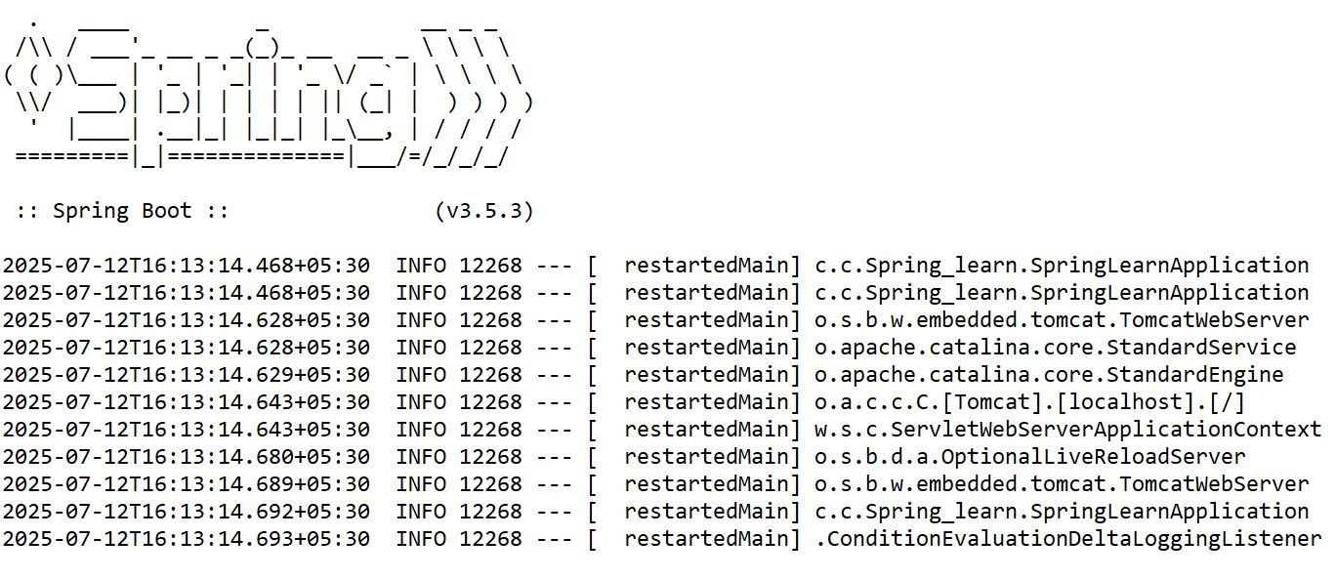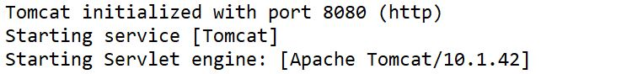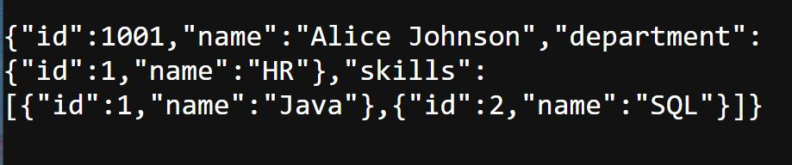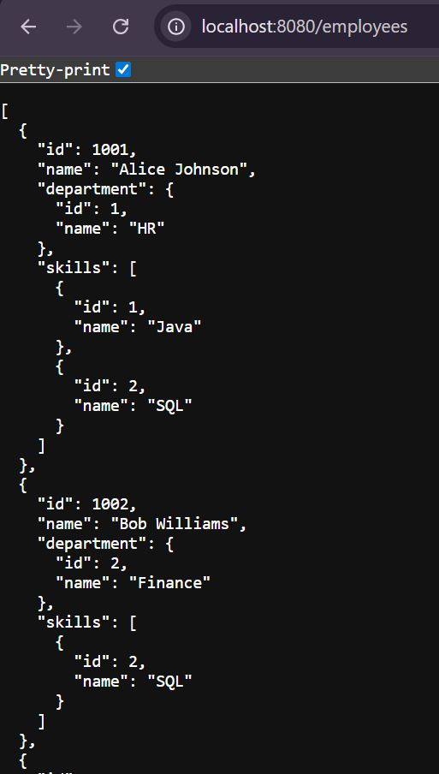

**Exercise 3.2) REST - Add New Employee (POST)**

package com.cognizant. Spring_learn.dao;

import com.cognizant.Spring_learn.model.Employee;

import org.springframework.context.ApplicationContext;

import org.springframework.context.support.ClassPathXmlApplicationContext;

import org.springframework.stereotype.Repository;

import java.util.List;

*@Repository*

public class EmployeeDao {

private static List<Employee> *employeeList*;

public List<Employee> getAllEmployees () {

if (*employeeList* == null) {

ApplicationContext context = new ClassPathXmlApplicationContext("employee.xml");

*employeeList* = context.getBean("employeeList", List.class);

}

return *employeeList*;

}

public Employee getEmployeeById(int id) {

List<Employee> list = getAllEmployees(); for (Employee e : list) {

if (e.getId()==id) {

return e;

}

}

return null;

}

public void addEmployee (Employee employee) {

getAllEmployees().add(employee);

}

}

package com.cognizant.Spring_learn.service;

import org.springframework.beans.factory.annotation.Autowired;

import org.springframework.stereotype.Service;

import com.cognizant.Spring_learn.dao.EmployeeDao;

*@Service*

public class EmployeeService {

*@Autowired*

private EmployeeDao employeeDao;

public List<Employee> getAllEmployees () {

return employeeDao.getAllEmployees();

}

public Employee getEmployeeById(int id) {

return employeeDao.getEmployeeById(id);

}

public void addEmployee (Employee employee) {

employeeDao.addEmployee (employee);

}

}

package com.cognizant.Spring_learn.controller;

import com.cognizant.Spring_learn.model.Employee;

import com.cognizant.Spring_learn.service.EmployeeService;

import org.slf4j.Logger;

import org.slf4j.LoggerFactory;

import org.springframework.beans.factory.annotation.Autowired;

import org.springframework.web.bind.annotation.GetMapping;

import org.springframework.web.bind.annotation.RestController;

import org.springframework.web.bind.annotation.PathVariable;

import org.springframework.web.bind.annotation.RequestBody;

import org.springframework.web.bind.annotation.PostMapping;

import java.util.List;

*@*RestController

public class EmployeeController{

private static final Logger ***logger*** = LoggerFactory.*getLogger*(EmployeeController.class);

*@Autowired*

private EmployeeService employeeService;

*@*GetMapping("/employees")

public List<Employee> getAllEmployees(){

***logger***.info("START - getAllEmployees()");

List<Employee> employeeList = employeeService.getAllEmployees();

***logger***.info("END - getAllEmployees()");

return employeeList;

}

*@*GetMapping("/employees/{id}")

public Employee getEmployeeById(*@*PathVariable int id) {

***logger***.info("START - getEmployeeById({})", id);

***logger***.info("END - getEmployeeById");

return employee;

}

*@*PostMapping("/employees")

public void addEmployee(*@*RequestBody Employee employee) {

***logger***.info("START - addEmployee()");

employeeService.addEmployee(employee);

***logger***.info("END - addEmployee()");

}

}

**OUTPUT:**

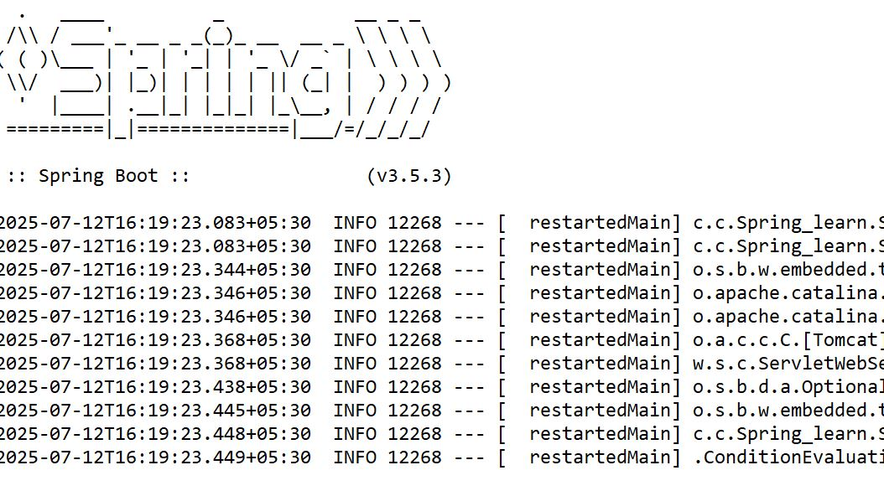

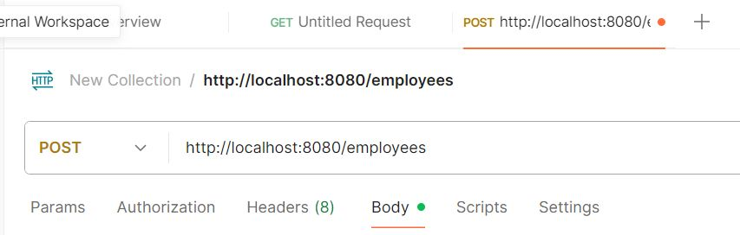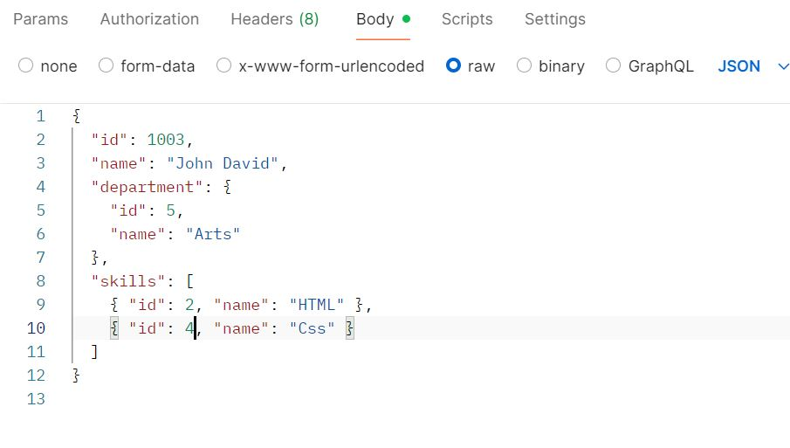

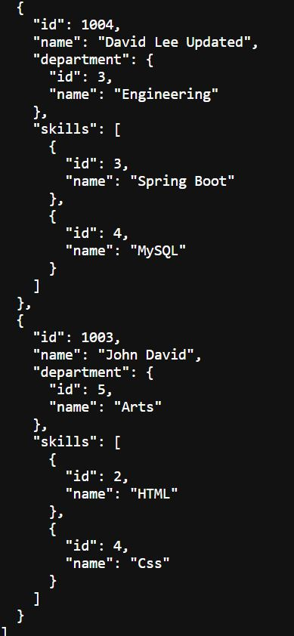

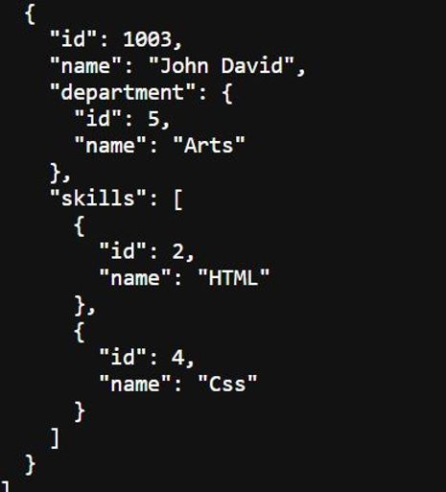

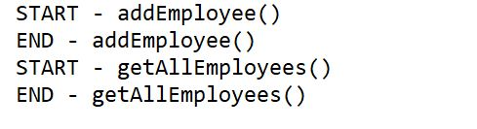

**Exercise 3.3) PUT – Update existing employee**

package com.cognizant. Spring_learn.controller;

import com.cognizant. Spring_learn.model.Employee;

*@*RestController

public class EmployeeController {

private static final Logger ***LOGGER*** = LoggerFactory. getLogger(EmployeeController.class);

*@*Autowired

private Employee Service employeeService;

*@*GetMapping("/employees")

public List<Employee> getAllEmployees () {

***LOGGER***.info("START - getAllEmployees ()");

List<Employee> employeeList = employeeService.getAllEmployees();

***LOGGER***.info("END - getAllEmployees ()");

return employeeList;

}

*@*GetMapping("/employees/{id}")

public Employee getEmployeeById(*@*PathVariable int id) {

***LOGGER***.info("START - get EmployeeById({})", id);

}

Employee employee = employeeService.getEmployeeById(id);

LOGGER.info("END getEmployeeById");

return employee;

-

*@*PostMapping("/employees")

public void add Employee (*@*RequestBody Employee employee) {

LOGGER.info("START - add Employee()");

employeeService.addEmployee (employee);

LOGGER.info("END - addEmployee()");

}

*@*PutMapping("/employees")

public void update Employee (*@*RequestBody Employee employee) {

LOGGER.info("START - updateEmployee()");

LOGGER.debug("Employee to update: {}", employee);

employeeService.updateEmployee (employee);

LOGGER.info("END - updateEmployee()");

}

}

package com.cognizant.Spring_learn.service;

import org.springframework.beans.factory.annotation.Autowired;

import org.springframework.stereotype.Service;

import com.cognizant.Spring_learn.dao.EmployeeDao;

*@Service*

public class EmployeeService {

*@Autowired*

private EmployeeDao employeeDao;

public List<Employee> getAllEmployees () {

return employeeDao.getAllEmployees();

}

public Employee getEmployeeById(int id) {

return employeeDao.getEmployeeById(id);

}

public void addEmployee (Employee employee) {

employeeDao.addEmployee (employee);

}

public void updateEmployee(Employee employee) {

Object employeeDao;

List<Employee> employees = employeeDao.getAllEmployees();

for(int i = 0; i < employees.size(); i++) {

if(employees.get(i).getId() == employee.getId()) {

employees.set(i, employee);

return;

}

}

}

OUTPUT:

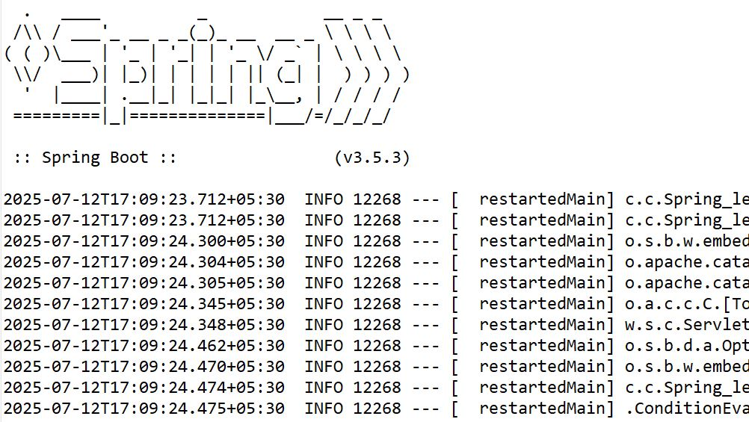

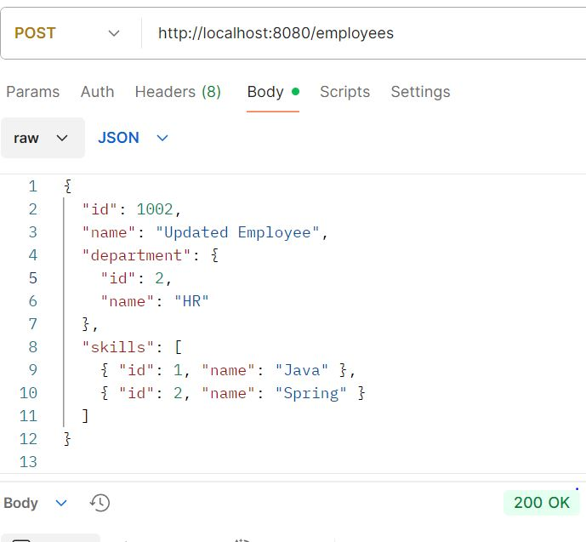

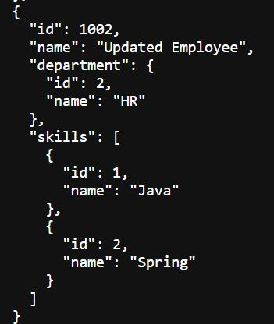

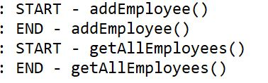

**Handson 3.4) DELETE – Remove an Employee by ID**

package com.cognizant. Spring_learn.controller;

import com.cognizant. Spring_learn.model.Employee;

*@*RestController

public class EmployeeController {

private static final Logger ***LOGGER*** = LoggerFactory. getLogger(EmployeeController.class);

*@Autowired*

private Employee Service employeeService;

*@GetMapping*("/employees")

public List<Employee> getAllEmployees () {

***LOGGER***.info("START - getAllEmployees ()");

List<Employee> employeeList = employeeService.getAllEmployees();

***LOGGER***.info("END - getAllEmployees ()");

return employeeList;

}

*@GetMapping*("/employees/{id}")

public Employee getEmployeeById(*@*PathVariable int id) {

***LOGGER***.info("START - get EmployeeById({})", id);

Employee employee = employeeService.getEmployeeById(id);

LOGGER.info("END getEmployeeById");

return employee;

}

*@PostMapping*("/employees")

public void add Employee (*@*RequestBody Employee employee) {

LOGGER.info("START - add Employee()");

employeeService.addEmployee (employee);

LOGGER.info("END - addEmployee()");

}

*@PutMapping*("/employees")

public void update Employee (*@*RequestBody Employee employee) {

LOGGER.info("START - updateEmployee()");

LOGGER.debug("Employee to update: {}", employee);

employeeService.updateEmployee (employee);

LOGGER.info("END - updateEmployee()");

}

*@DeleteMapping*("/employees/{id}")

public Employee deleteEmployeeById(*@*PathVariable int id) {

***LOGGER***.info("START - delete EmployeeById({})", id);

employeeService.deleteEmployeeById(id);

LOGGER.info("END deleteEmployeeById");

}

}

package com.cognizant.Spring_learn.service;

import org.springframework.beans.factory.annotation.Autowired;

import org.springframework.stereotype.Service;

import com.cognizant.Spring_learn.dao.EmployeeDao;

*@Service*

public class EmployeeService {

*@Autowired*

private EmployeeDao employeeDao;

public List<Employee> getAllEmployees () {

return employeeDao.getAllEmployees();

}

public Employee getEmployeeById(int id) {

return employeeDao.getEmployeeById(id);

}

public void addEmployee (Employee employee) {

employeeDao.addEmployee (employee);

}

public void updateEmployee(Employee employee) {

List<Employee> employees =

employeeDao.getAllEmployees();

for(int i = 0; i < employees.size(); i++) {

if(employees.get(i).getId() == employee.getId()) {

employees.set(i, employee);

return;

}

}

public void deleteEmployee(int id){

employeeDao.deleteEmployee (id);

}

}

package com.cognizant.Spring_learn.dao;

import com.cognizant. Spring_learn.model.Employee; import org.springframework.context.ApplicationContext;

import org.springframework.context.support.

ClassPathXmlApplicationContext;

import org.springframework. stereotype. Repository;

import java.util.List;

*@Repository*

public class EmployeeDao {

private static List<Employee> *employeeList*;

public List<Employee> getAllEmployees() {

if (employeeList == null) { ApplicationContext context = new

}

ClassPathXmlApplicationContext("employee.xml");

employeeList = context.getBean("employeeList", List.class);

return employeeList;

}

public Employee getEmployeeById(int id) {

List<Employee> list = getAllEmployees();

for(Employee e : list) {

if(e.getId() == id) return e;

}

return null;

}

public void addEmployee(Employee employee) {

getAllEmployees().add(employee);

}

public void deleteEmployee(int id) {

List<Employee> employees = getAllEmployees();

employees.removeIf(e -> e.getId() == id);

}

}

OUTPUT:

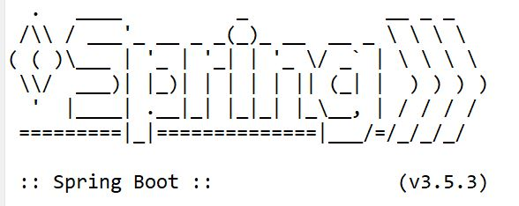

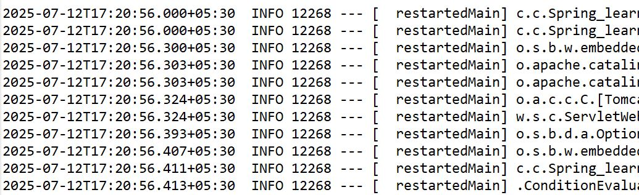

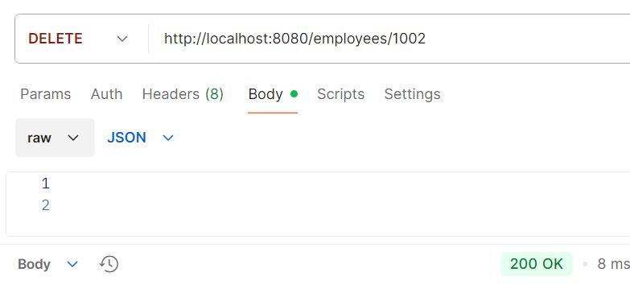

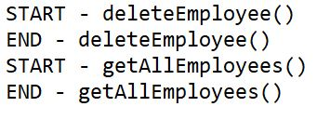

**Handson - 5: Create REST service for department**

<?xml version="1.0" encoding="UTF-8"?>

<beans xmlns="http://www.springframework.org/schema/beans"

xmlns:xsi="http://www.w3.org/2001/XMLSchema-instance"

xsi:schemaLocation="http://www.springframework.org/schema/beans

https://www.springframework.org/schema/beans/spring-beans.xsd">

<bean id="department List" class="java.util.ArrayList">

<constructor-arg>

<list>

<bean class="com.cognizant. Spring_learn.model. Department">

<property name="id" value="1"/>

<property name="name" value="HR"/>

</bean>

<bean class="com.cognizant. Spring_learn.model.Department">

<property name="id" value="2"/>

<property name="name" value="Finance"/>

</bean>

</list>

</constructor-arg>

</bean>

</beans>

package com.cognizant.Spring_learn.model;

public class Department{

private int id;

private String name;

public int getId() {

return id;

}

public Department() {}

public void setId(int id) {

this.id = id;

}

public String getName() {

return name;

}

public void setName(String name) {

this.name = name;

}

*@Override*

public String toString() {

return "Department [id=" + id + ", name=" + name + "]";

}

}

package com.cognizant. Spring_learn.service;

import java.util.List;

import org.springframework.beans.factory.annotation. Autowired;

import org.springframework. stereotype.Service;

import org.springframework.beans.factory.annotation.Qualifier;

import com.cognizant. Spring_learn.model.Department;

*@Service*

public class DepartmentService {

*@Autowired*

*@Qualifier*("departmentList")

private List<Department> departmentList;

public List<Department> getAllDepartments() {

return departmentList;

}

}

package com.cognizant. Spring_learn.controller;

import java.util.List;

import org.springframework.beans.factory.annotation.Autowired;

import org.springframework.web.bind.annotation.GetMapping;

import org.springframework.web.bind.annotation. RestController;

import com.cognizant.Spring_learn.model.Department;

import com.cognizant. Spring_learn.service.DepartmentService;

*@*RestController

public class DepartmentController {

*@Autowired*

private DepartmentService departmentService;

*@GetMapping*("/departments")

public List<Department> getAllDepartments() {

return departmentService.getAllDepartments();

}

}

OUTPUT:

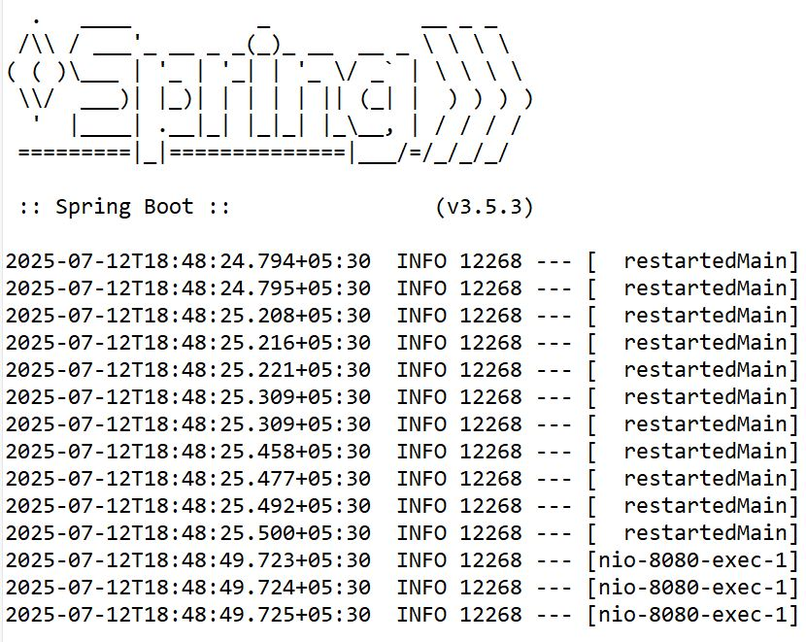

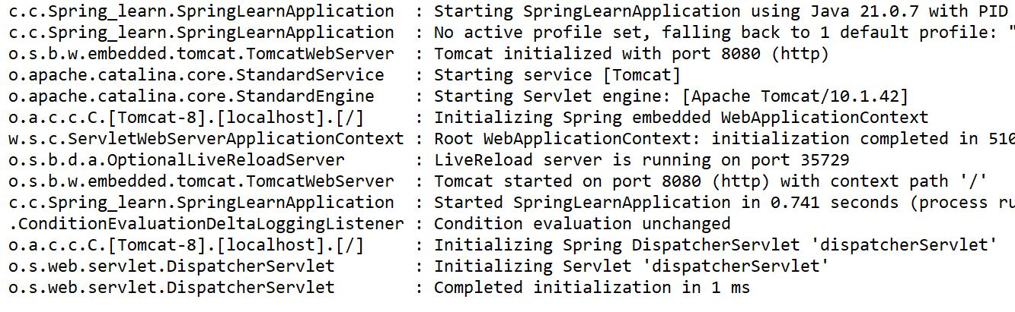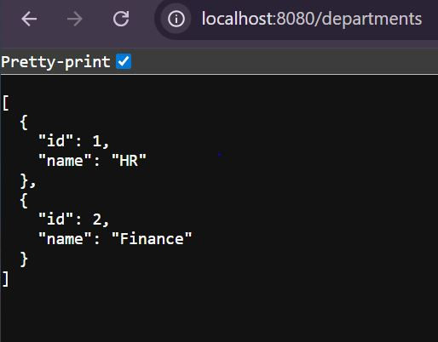

package com.cognizant.Spring_learn;

import org.springframework.boot.SpringApplication;

import org.springframework.boot.autoconfigure.SpringBootApplication;

import org.springframework.context.annotation.aspectj.ImportResource;

*@SpringBootApplication*

*@ImportResource*("classpath:department.xml")

public class SpringLearnApplication{

public static void main(String[] args) {

SpringApplication.run(SpringLearnApplication.class, args)

}

}